Amylelia

User manual and instructions

User manuals should be given for the design. These manuals should be appropriate for use by either the sponsor or the end user (if the design is a product marketed by the sponsor). These should be given in the form of a step-by-step guide to using the product. A troubleshooting and common-problems section can also be included if necessary.

---------------------------------------------------------------------------------------------------------------------

User Manual and Instructions

By, Amyleila Mejia

# Table of Contents

**Table of Contents** **1**

**Introduction** **2**

**Maintenance Instructions** **2**

**Parts and Materials** **2**

Hololens Gen 1 Components 3

**User Manual & Instructions** **3**

**1.)Turn ON** **3**

Table 1: Hololens proper adjustment methods and handling. 4

Figure 2: Power device overview. Charging and button locations can be clearly seen. 5

**2.) Brightness and Volume Adjustment** **5**

Figure 4: Power 6

**3.) Unity Game Engine Project Selection** **6**

Figure 5: Unity Game Engine list of projects to select from. 6

Figure 6: Unity Game Engine Project opened view. 7

**4.) Unity Game ENgine Build Settings** **8**

Figure 7: Unity Game Engine Project view using file drop down menu to build game settings. 8

**5.) Universal Windows Platform Configuration Settings Using Unity Game Engine** **8**

Table 2: Universal Windows Platform configuration settings. 9

Figure 8: Unity game engine project build settings view. 10

**6.) Using the Hololens Emulator for App Launch** **10**

**7.) Using the App** **10**

Figure 9: Hololens Emulator view of app launch. 10

**8.) System Shutdown** **11**

**Appendix** **12**

# Introduction

Dr. Omid Semiari proposed a senior design project that was designed to increase an artificial reality device’s hardware performance by creating and implementing a remote rendering application. This project would prove that utilizing a host computer to conduct all the application’s processing would indeed improve the performance and battery life of an AR headset, in our case the HoloLens 1. In order to use our remote rendering application with a HoloLens 1, we have included some manuals and instructions below.

# Maintenance Instructions

For troubleshooting the HoloLens the Microsoft Ignite Documentation Online is a great source to reference. This documentation remains up to date on issues any owner of the HoloLens has faced, along with a detailed description on what to do in these situations. This information can be found at: [HoloLens (1st gen) hardware | Microsoft Learn](https://learn.microsoft.com/en-us/hololens/hololens1-hardware). This resource will also be extremely useful for users because it contains user instructions and provides links to online communities that can help with any problems that might come up.

# Parts and Materials

1. Hololens Gen 1

### Hololens Gen 1 Components

1. Router
2. Cables used for Router
3. Host Computer
4. 2 Handheld Remotes

# User Manual & Instructions

# 1.)Turn ON

***Figure 1:*** Desktop version of the Unity Game Engine Launcher.

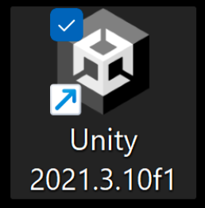

1. First place the HoloLens 1 on your head, ensuring that the device is properly sitting in place and not loose. An unsecured headset could end in injury or damage to the device. Please see figure 1 for more information on HoloLens adjustment methods.
2. To turn on the HoloLens Gen 1 there is a button located on the back of the headset (see figure 2). Hold this button down for four seconds.
3. Turning on the device also requires turning on the app for full interaction.
4. Open the project file in the host computer. The icon the user will need to find on the host computer desktop can be referenced in figure 1.
5. The user will enable and launch the app, figure 1, by interacting with the Unity Game Engine and double clicking on the app icon.

### Figure 1: Hololens proper adjustment methods and handling.

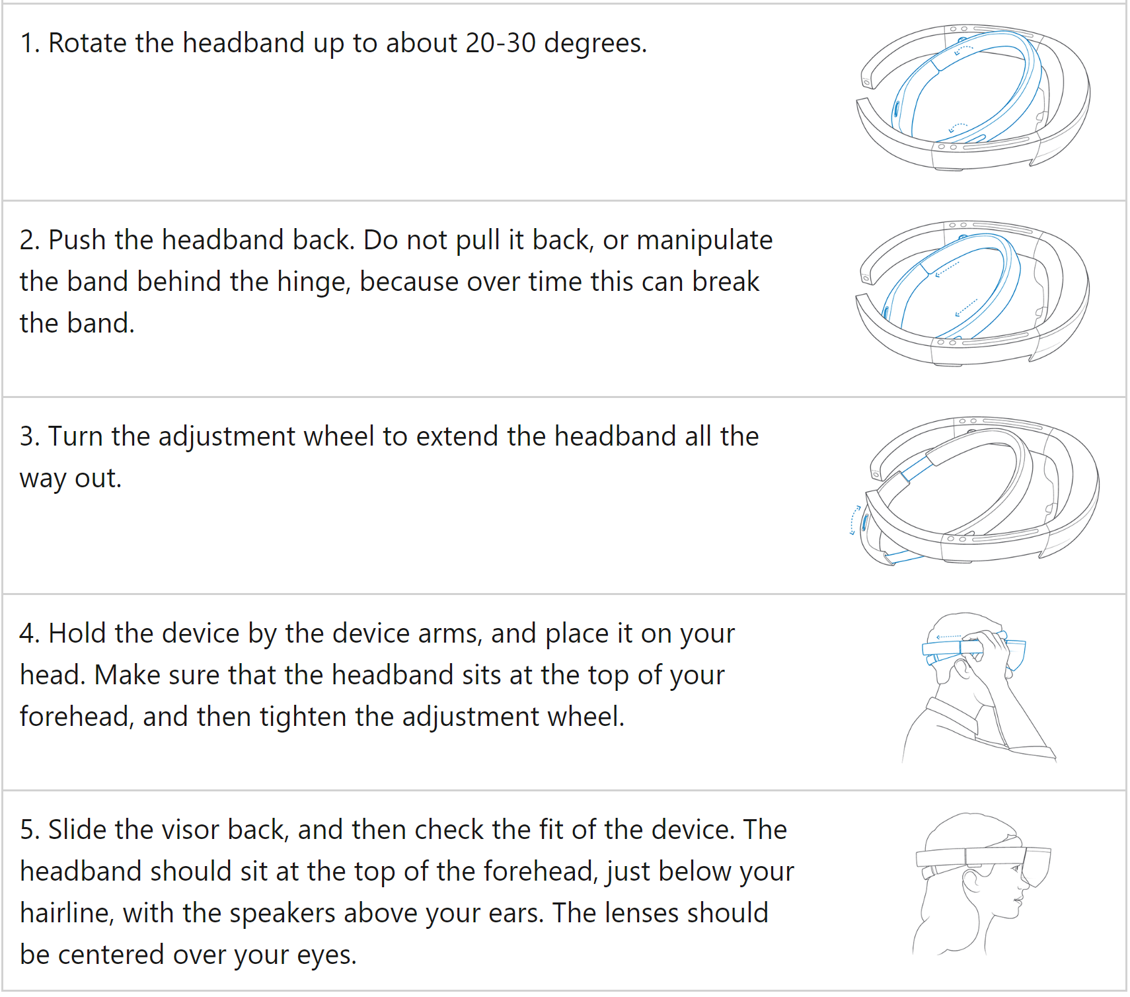

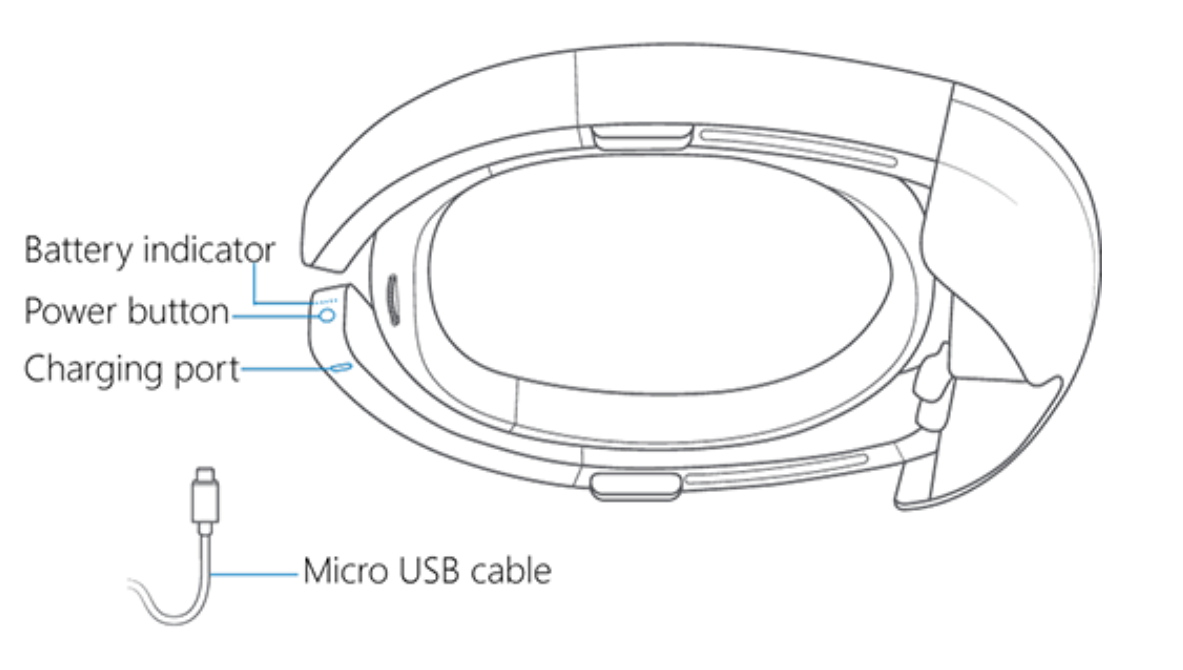

### ***Figure 2:*** Power device overview. Charging and button locations can be clearly seen.

# 2.) Brightness and Volume Adjustment

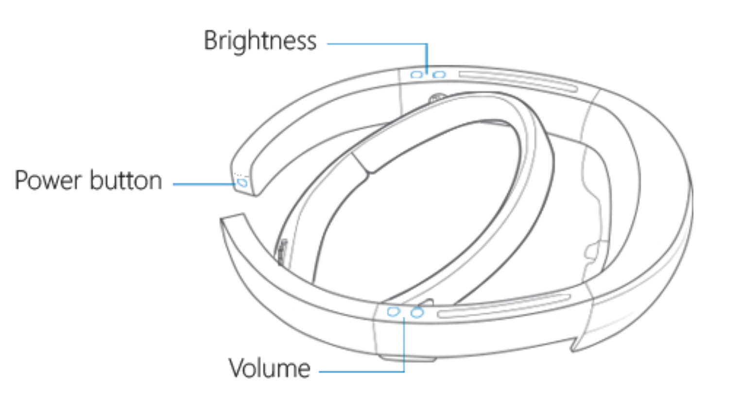

Table 1 demonstrates the steps that are necessary for the adjustment process to take place.

1. Rotate the inner headband to about 30 degrees.
2. Put the headband on to secure Hololens on your head.
3. There is an adjustment wheel located in the back of the inner headband that can be turned to adjust the headband to the circumference of the head.
4. Make sure to adjust the tightness that supports the Hololens and is not loose otherwise there could be injury in to the person or damage to the device

### ***Figure 4:*** Power

# 3.) Unity Game Engine Project Selection

1. Once the user double clicks the app icon the project drop down menu will be opened in the Unity Game Engine and can be referenced in figure 5.
2. The user will then proceed to go to the drop down menu under the projects file, figure 5, and find the corresponding project to select. This will open up that project. The example from figure 5 is the folder my_first_unity.

### ***Figure 5:*** Unity Game Engine list of projects to select from.

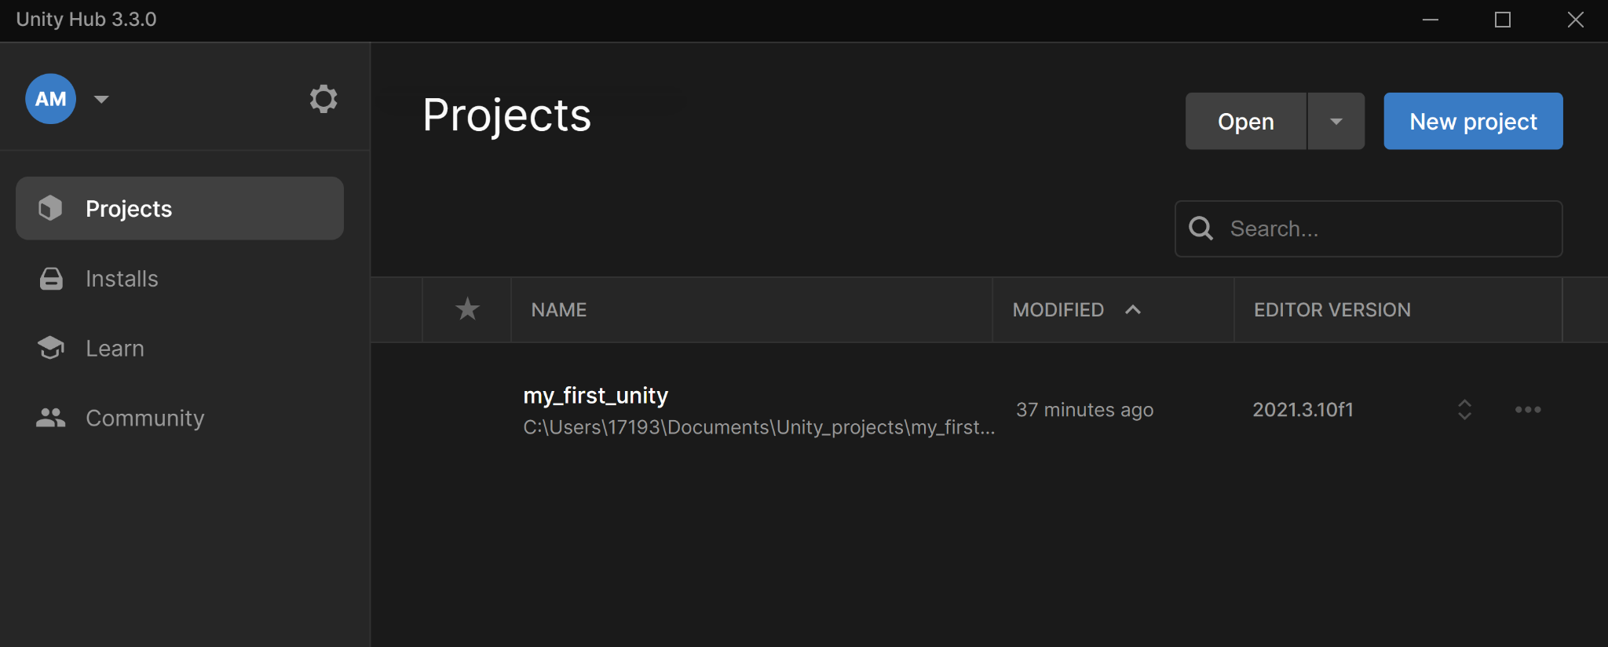

# 4.) Unity Game ENgine Build Settings

### ***Figure 6:*** Unity Game Engine Project opened view.

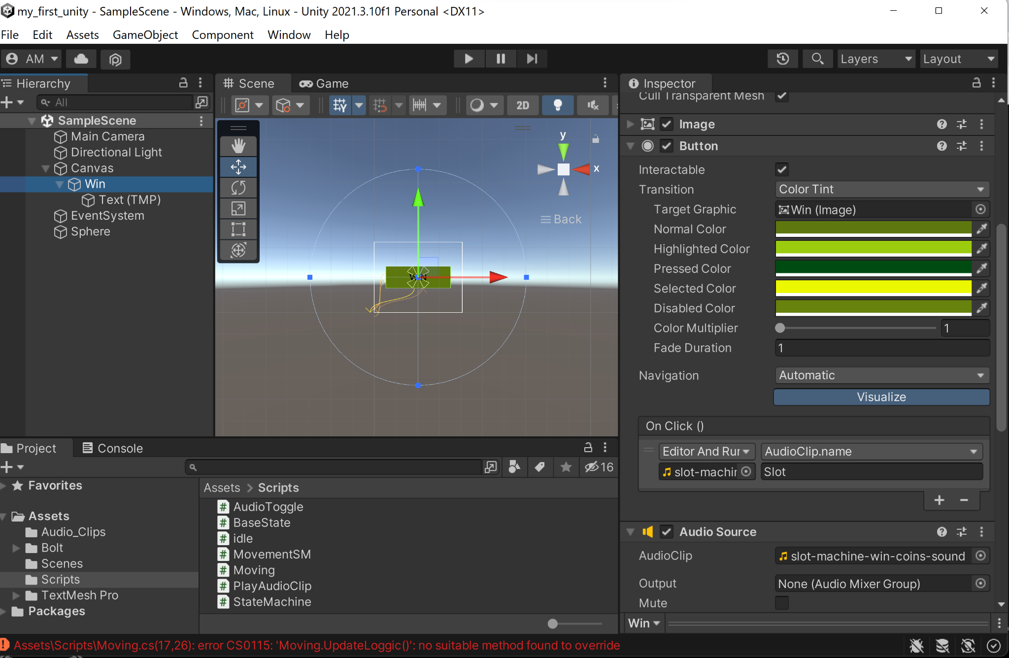

# 

### ***Figure 7:*** Unity Game Engine Project view using file drop down menu to build game settings.

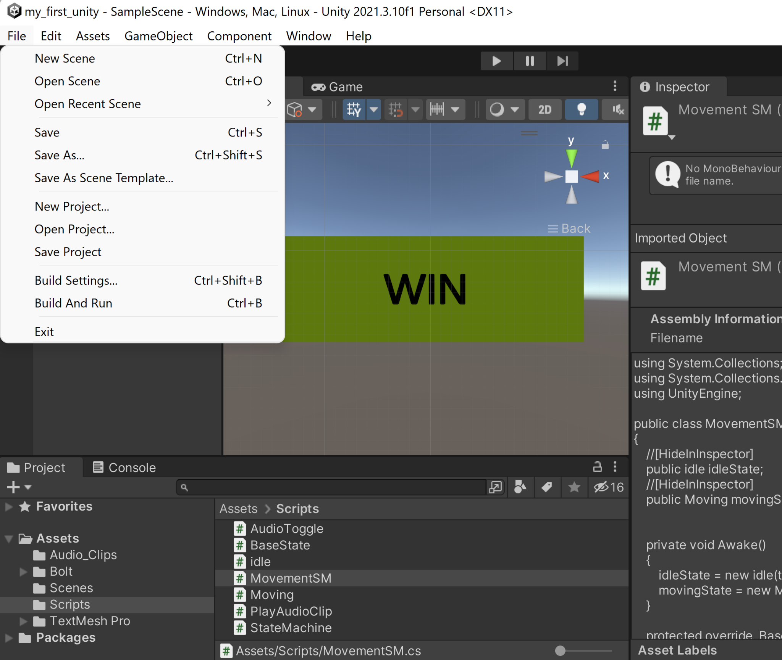

1. When the user successfully opens up the project file following figure 5 the window the user will see if using the Unity 2021.3.10f1 version will look like figure 6.
2. The user will need to configure the game settings in the unity game engine by selecting the file drop down menu and selecting build settings. This view can be found in figure 7.

# 5.) Universal Windows Platform Configuration Settings Using Unity Game Engine

The build settings will provide access to the Universal Windows Platform settings, figure 8. In order to successfully launch the project onto the Hololens the user will need to configure the Universal Windows Platform settings to properly render the game.

1. The first step in this process is to select the proper platform in use which in this case must be the Universal Windows Platform.
2. The user must first make sure to select the “Add Open Scenes”, this will automatically select the current project scene that is open and enable the platform configuration settings for that particular Scene/Project.
3. The platform settings must include the following configuration which can be referenced in table 2 and figure 8.
4. Once these settings have been configured the user must press build and run.

Table 2: Universal Windows Platform configuration settings.

### ***Figure 8:*** Unity game engine project build settings view.

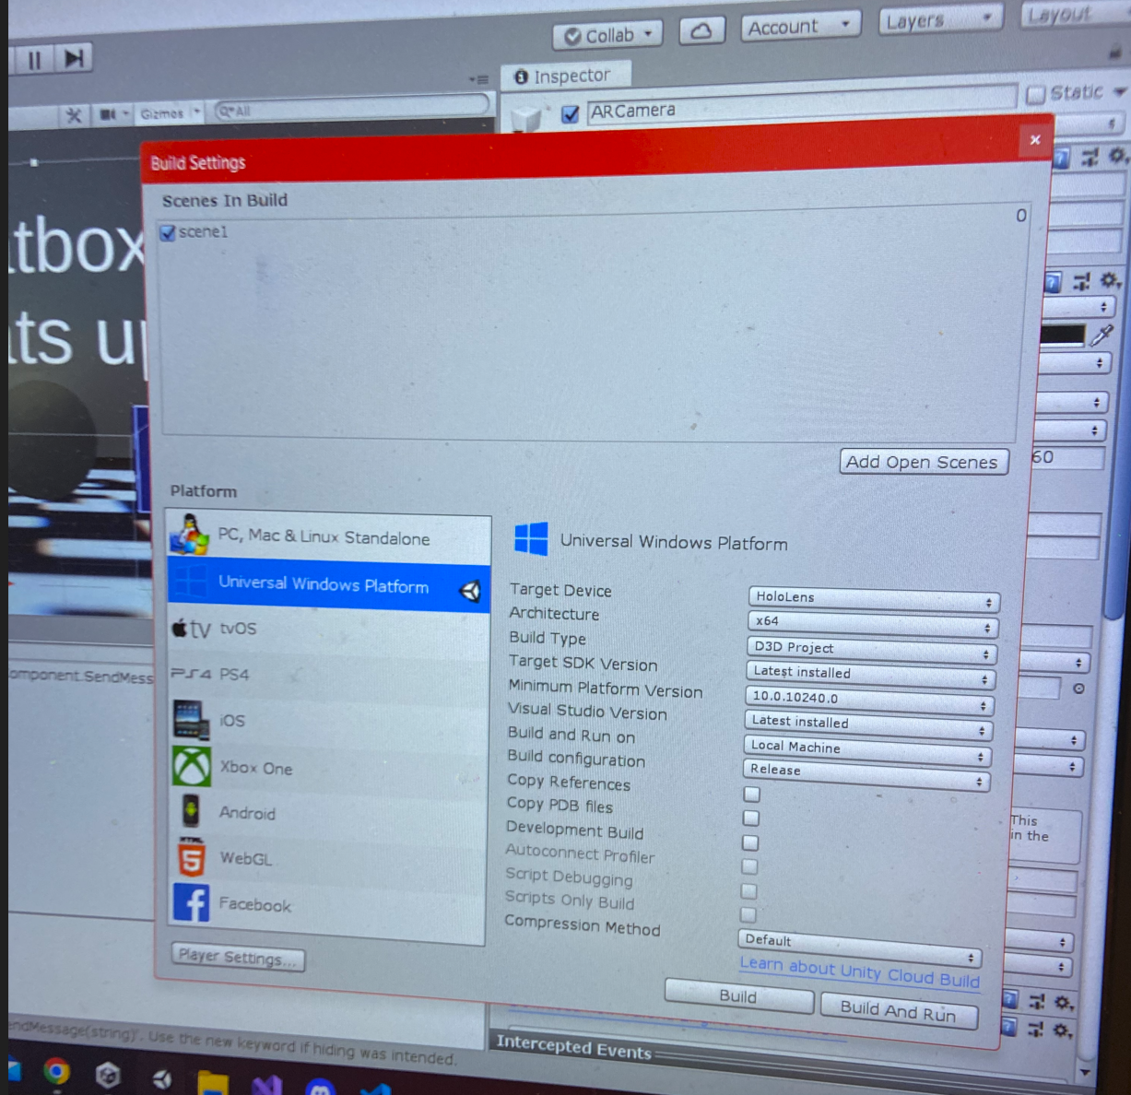

# 6.) Using the Hololens Emulator for App Launch

If the user decides to use the Hololens Emulator the configuration can vary slightly.

1. First the solution configuration setting must be changed from debug to master found on the upper left corner. That gives the user the option to run the project on the device, the Hololens.
2. Make sure to have the Hololens powered on and situated on head when pressing the start button on the Hololens Emulator because the start will automatically launch the app on the Hololens.

# 7.) Using the App

### ***Figure 9:*** Hololens Emulator view of app launch.

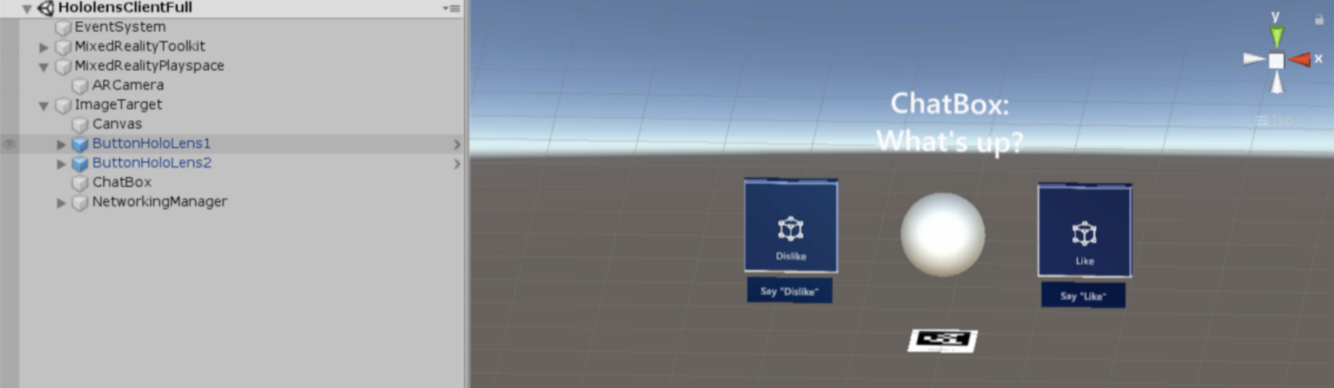

1. Click on the App icon using hand held remotes.

Once the app launches, the HoloLens comes with a pair of hand held remotes one for each hand, the user will be able to use either remote to click on the app button to launch the game. The button will look like the buttons dislike and like in figure 9. Using the hand held remotes the user will be able to launch the app by clicking the app button.

Once the app is launched the user will no longer need to configure settings or click on anything. The hololens will interact with the user through audio events and graphical overlays but the user will no longer need to do anything until the user needs to shut down the system.

# 8.) System Shutdown

Power the Hololens down. Close the Emulator by exiting the scene using the x to close down the game. The user can also use the Unity Game Engine to press the start and stop button on the top of the scene, figure 10.

***Figure 10:*** Unity game engine end scene/project. The start and stop buttons are located right above.

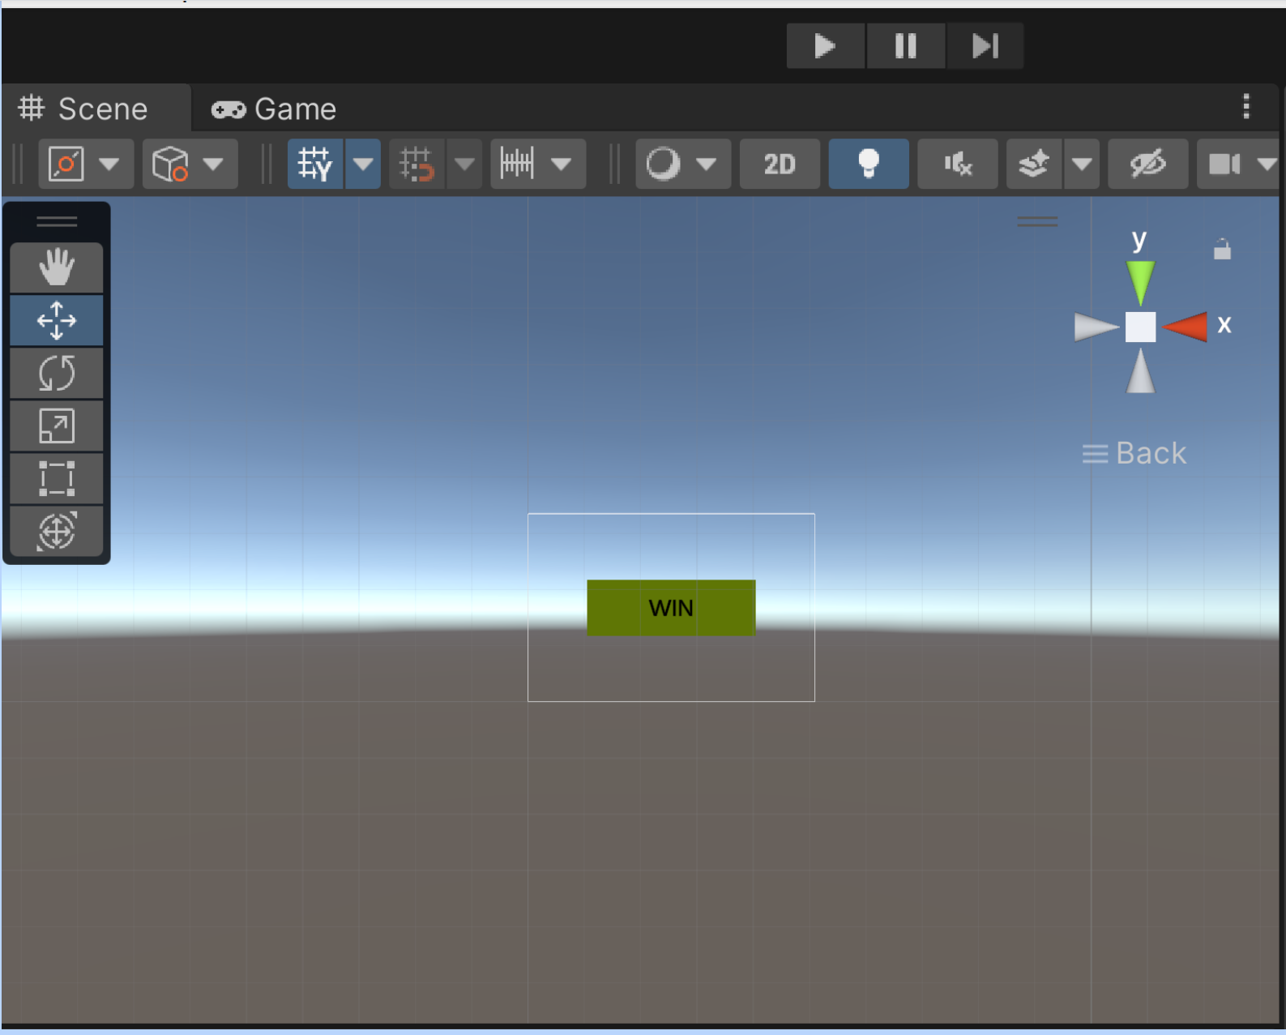

# Appendix

[1] Unknown. “Microsoft Ignite.” Learn Microsoft. URL (accessed October 2, 2022). [Prepare a new HoloLens | Microsoft Learn](https://learn.microsoft.com/en-us/hololens/hololens1-setup)